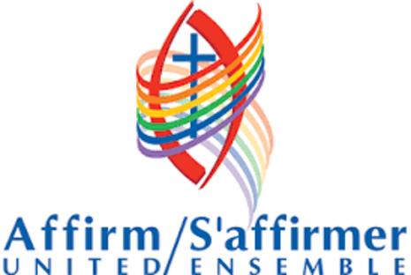

In July I mentioned that a group of ministers from the United Church of Canada had sent newly elected premier Doug Ford an open letter. The full text of the letter can be found at ontariouccministers.org but one section states, “We value teaching comprehensive sexual education in our schools and believe strongly that knowledge leads to better choices and better health outcomes.”

One of the controversial parts of the sex ed curriculum in our province has been that dealing with sexual orientation and gender identity. Some argue that in dealing with these topics we are promoting sexual and gender expressions beyond the traditional heterosexual binary understanding. We believe that such understanding does not promote but does empower. Young people who are confused about their place in a predominantly heterosexual culture are given language to describe their feelings and experience. And the children who surround them are made more compassionate toward their classmates.

Many of the concerns raised in the letter to the Premier centre on an ethic of caring for the vulnerable. The economy is important but balancing budgets should not be done on the backs of the poor. Improvements to health care are important but especially around addiction treatment. Sexual education is important, especially for groups traditionally marginalized such as the LGBTQ community.

Over 200 ministers of the United Church in Ontario signed the open letter to our Premier. In our province churches are often seen as upholding conservative social values. It is an important witness to have Christians expressing progressive understandings on these issues. Becoming an Affirming Ministry would be one such expression.

Russell Wardell

