Our Statement of Purpose
As a community of faith led by the Spirit, we welcome all to worship God and live in loving, just and respectful relationship with each other, our neighbours and the earth. Inspired by the life and ministry of Jesus Christ we strive to recognize the light of God in each person regardless of age, race, physical or mental ability, sexual orientation, gender identity and gender expression, economic status or any other category by which the world may seek to divide. We challenge ourselves to deepen our relationship to God, to see the light of the divine in each person and in all creation, and to live the faith we proclaim in every aspect of our lives.
Our Week at a Glance – July 1, 2018
The flowers today have been placed by Garry & Ruth Charter, in loving memory of Bob Newberry and Doreen Charter.

THIS WEEK AT TSA:

Mon. July 2 Office Closed

Wed. July 4 Bible Study – Marian Roffey, 12:00
AUDIO SYSTEM July 1 – Merv Kusluski
July 8 – Debbie McDermid
COUNTING OFFERING July 1: Bev Davis & Peter Raaphorst
July 8: Leslee Gervais & Marg Crozier
MEALS ON WHEELS July 1 – Brenda Kellar & helper
July 8 – Shawn Panesar & Bennett
Annual Chicken BBQ: Mark your calendar!! This year’s annual chicken barbeque has been set for Thursday, July 19, 2018. Sign-up sheets are in the Narthex. As this is our major fundraiser of the year, please sign up to help us with this large event and let’s make this a success again!
“The Teaching of the Wheel of Life”: Join Algonquin Elder Pat Aird at TSA on Saturday July 28 from 10am-4pm to learn more about Algonquin spiritual wisdom. The cost is $30 and includes a booklet, lunch and snacks. Subsidies are available if needed (see Russell). Pre-registration is required. The deadline for registration is July 20. This event is part of our church’s process of reconciliation with indigenous peoples.
Summer Coffee Roster: TSA Coffee Volunteers Needed: Please join us downstairs in the refreshing coolness of Stewart Hall for fellowship after the service. Thank you to all the helpers who prepare and clean up.

Would you like to help with fellowship
After Russell's finished prayers
We would appreciate some help from you
In Stewart Hall, just down the stairs

We need some help to brew the coffee
And make a pot of tea
Then all our congregation
Can enjoy it hassle free

We will provide the cookies
Or a fancy little cake
But we need some helping hands
To run this coffee break

Please sign up in the Narthex
Missing Library DVD: If you have the DVD, Prayers for Bobby, would you please see Beulah in the Library.
From MPCF – TSA Photo Booth: Thanks to Mickey McDonald we now have pictures of about 85 people in our TSA family. Keep smiling and watch for an announcement about the re-opening date of the Photo Booth after the summer.
Conservation Agriculture 2018: TSA Supports the Canadian Foodgrains Bank
The raised bed vegetable garden at the corner of Plaunt and Quarry is a visual reminder that TSA supports the work of Canadian Foodgrains Bank to end world hunger. At the June 3 family picnic kids and adults planted beets, beans, tomatoes, red cabbage and kale in our raised bed. We gathered around the garden as Russell offered a prayer of blessing. Thanks to the donors of varied plants and seeds, our TSA garden is well underway.
Many small-scale farmers in Africa struggle to grow enough food year-round for their families. Poor farming methods, erratic weather, erosion, drought and open grazing of livestock are some of the factors that limit agricultural production. Now entering year 4 of a 5-year commitment working with partners in the Wolayta district of Ethiopia, Canadian Foodgrains Bank member TearFund Canada is introducing and promoting conservation agriculture techniques to 8,500 farm households (about 42,500 people).
Conservation agriculture is a farming approach that uses minimal soil disturbance, crop rotations, cover crops and mulching to improve soil health and fertility and increase production. The training includes community meetings, famer field days and farmer field schools, and other educational activities. Savings and loans groups are also being introduced.
As you pass by the garden, please pray for farming families and their supporters as they strive for a future without hunger.

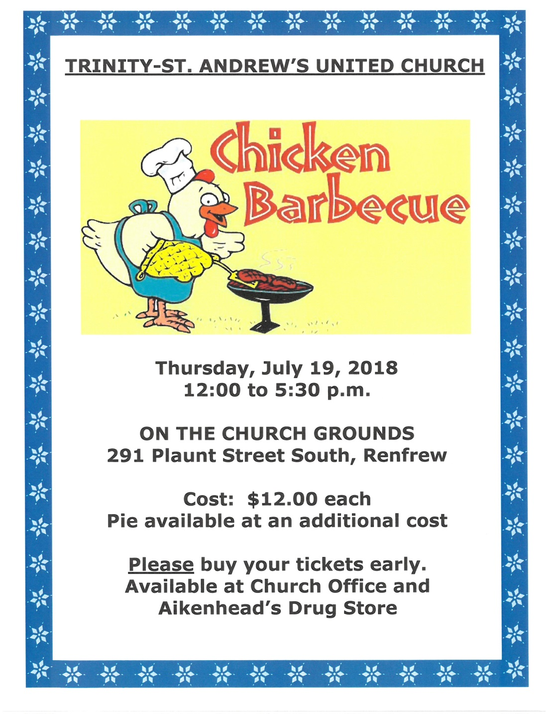

Radical Welcome
United Church partner Affirm United offers a process, the Affirming Ministry Program, to help all ministries truly welcome people of all sexual orientations and gender identities. Our gifts for Mission & Service support the Affirming process. Our planning and conversations are made possible by your support for Mission & Service.
Any ministry in the United Church can become Affirming, but so far there are no Affirming outdoor ministries or camps. Camping experiences can offer spaces filled with friendship, faith, community, and a deep appreciation of God’s diverse world. But sometimes differences can create barriers. Campers or staff with diverse ethnicities, economic statuses, sexual orientations, and gender identities or expressions can be pushed to the side, even unintentionally.
This year, to coincide with the 30th anniversary of the church’s 1988 decision to welcome LGBTQ+ people into full membership and ministry, all United Church outdoor and camping ministries have been invited to consider becoming Affirming. In an exciting pilot project, three United Church camping ministries have agreed to test the Affirming Ministry Program and to work with Affirm United to develop a process that can easily be used with all outdoor ministries.
In the future, we hope to hear more words like these from a camper at the United Church’s Camp Kidston in Nova Scotia: “[Here] I felt truly safe and free to be who I am. I began to understand that I am part of creation, a reflection of the Divine—all of me—acceptable and loved.”
We hope that our United Church Outdoor/Camping Ministries will publicly and intentionally embrace all differences.
If Mission & Service giving is already a regular part of your life, thank you so much! If you have not given, please join me in making Mission & Service giving a regular part of your life of faith. Loving our neighbour is at the heart of our Mission & Service.

